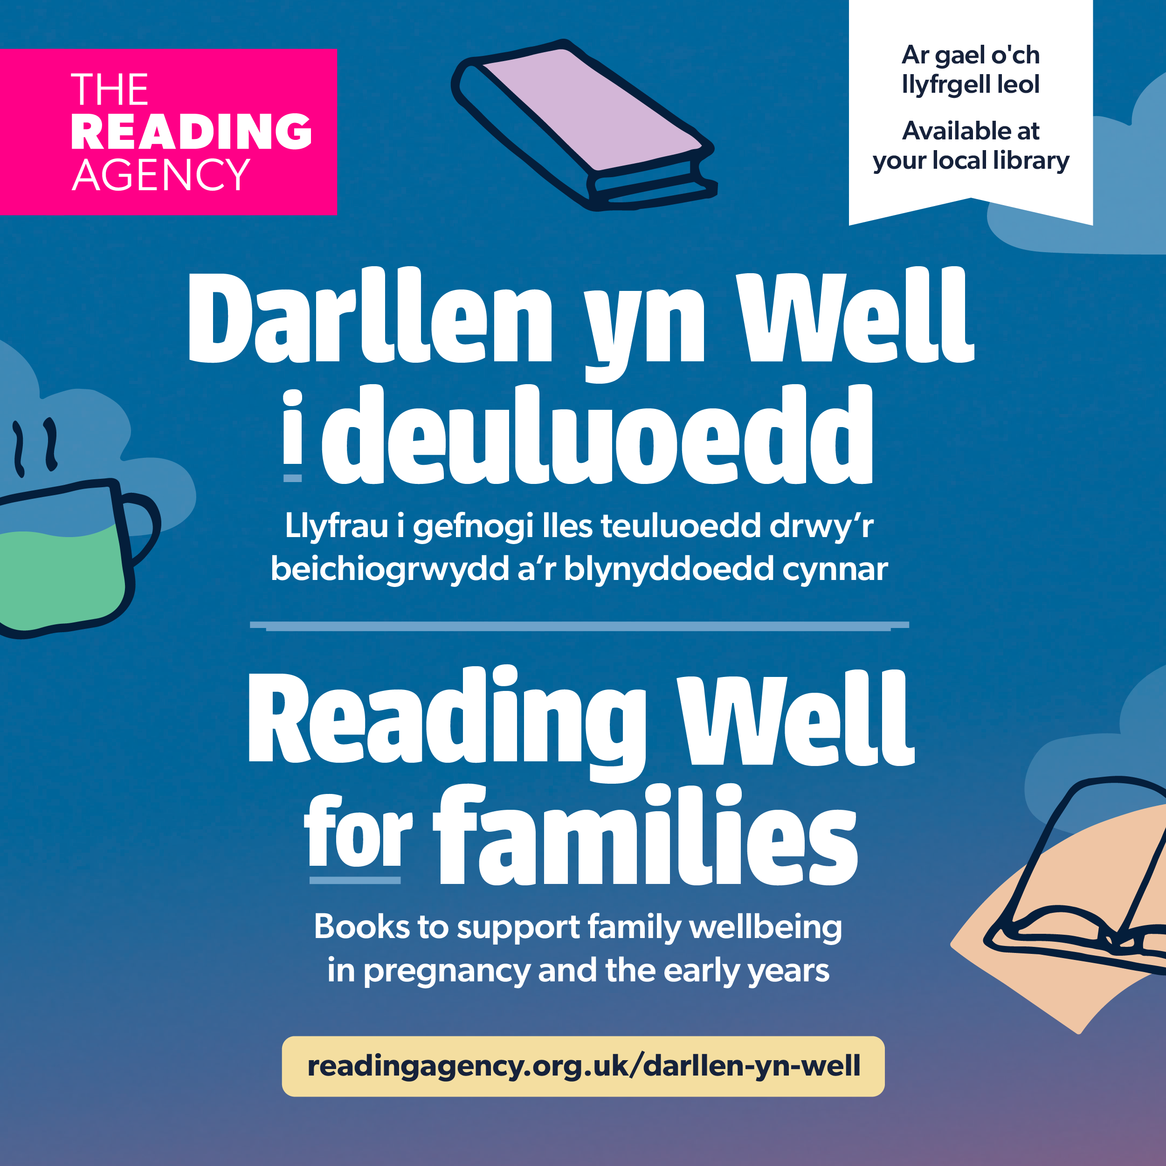

Darllen yn Well i deuluoedd | Reading Well for families
Promotional toolkit
Scheme launch date: 10 June 2025
Contents
Introduction to Darllen yn Well i deuluoedd/ Reading Well for families 2
Library staff awareness 5
E-lending offer 6
Promotional materials and resources 7
Activity and event ideas 8
Display and promotion ideas 9
Social media and digital promotion 10
Health sector outreach 16
Feedback 16

Introduction to Darllen yn Well i deuluoedd/ Reading Well for families
What is Darllen yn Well/ Reading Well?
Darllen yn Well/ Reading Well has been developed by The Reading Agency in partnership with Society of Chief Librarians Cymru (SCL Cymru) and Libraries Connected and is delivered with public libraries. The scheme is funded by Welsh Government and Arts Council England.

Darllen yn Well/ Reading Well booklists support people to understand and manage their health and wellbeing using helpful reading. There are schemes covering dementia and mental health for adults, teens and children, as well as the new scheme for families. In Wales, the programme is delivered bilingually with support from Welsh Government.
Over 3.9 million Reading Well books have been borrowed from libraries since 2013. For more information on Reading Well, please visit www.readingagency.org.uk/reading-well/reading-well-in-wales

Darllen yn Well i deuluoedd/ Reading Well for families
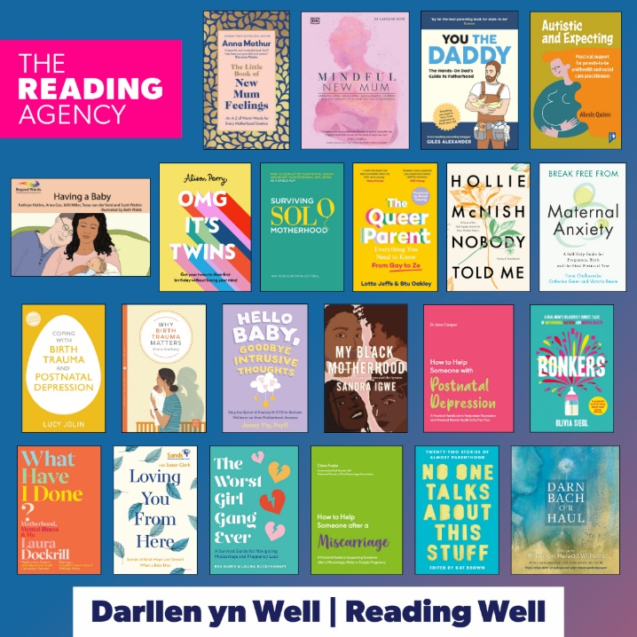
Darllen yn Well i deuluoedd/ Reading Well for families recommends helpful reading to support parents and carers to look after their wellbeing in pregnancy and the early years (from conception to aged two). The books provide information on wellbeing, mental health and coping with loss.
The scheme is aimed at adults and includes a range of recommended books and supporting digital resources.
Some of the recommended books provide information and advice; there are also personal stories, illustrated books and poetry. The list also includes a wide range of formats including eBooks and audiobooks.
The collection of books has been chosen and endorsed by leading health professionals and co-produced with people with lived experience.
Darllen yn Well i deuluoedd/ Reading Well for families is supported by: Action on Postpartum Psychosis, Association for Infant Mental Health, Association for Post-Natal Illness, British Psychological Society, Centre for Mental Health, Institute of Health Visiting, MASIC Foundation, Maternal Mental Health Alliance, Maternal OCD, Mental Health Foundation, Mind, National Association of Primary Care, NHS Wales Executive, PANDAS Foundation, Parent-Infant Foundation, Patient Information Forum, Royal College of General Practitioners, Royal College of Nursing, Royal College of Psychiatrists, Sands, The Motherhood Group, Tommy’s.
The scheme’s co-production partner, Maternal Mental Health Alliance, ensured the views of parents with lived experience of perinatal mental health conditions from Wales and England informed all aspects of developing this list.

Launch
The new Darllen yn Well i deuluoedd/ Reading Well for families scheme launches in Wales and England on Tuesday 10 June 2025.
We will be celebrating the new scheme throughout the week and beyond. We have gathered some ideas and resources in this toolkit to help you to get involved.
Please remember when planning local publicity and launches that the booklist is embargoed until 00.01 on 10 June 2025 and should not be shared publicly before then.
Any local launches/events should take place on or after 10 June 2025. (See the ‘Activity and event ideas’ section in this toolkit for launch day celebration inspiration.) You can download a local press release template to help promote Darllen yn Well i deuluoedd/ Reading Well for families in your area.
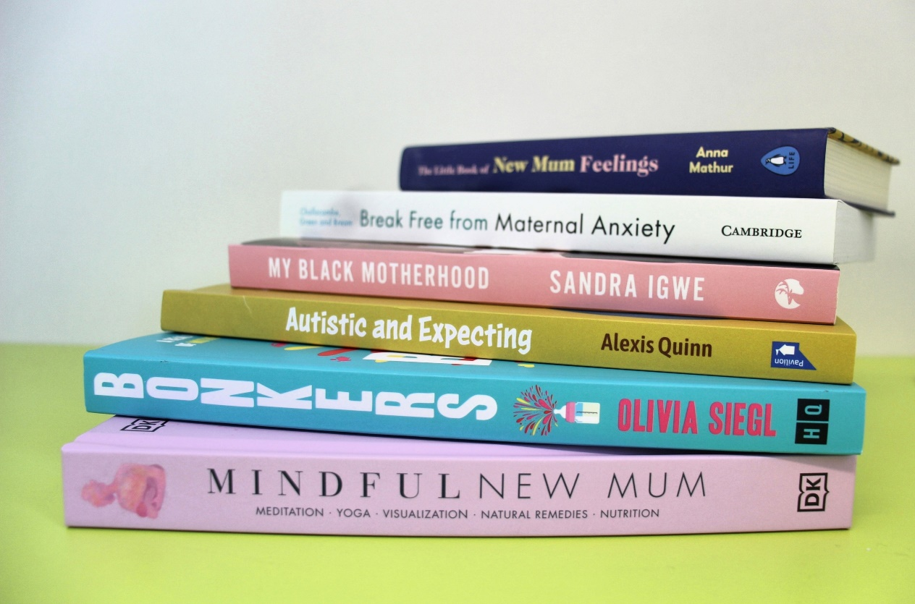

Library staff awareness
Library staff play an essential role in promoting Darllen yn Well/ Reading Well and making the public aware of expert endorsed health information. To help ensure staff are confident in promoting it, you may want to:
- Provide background information about Darllen yn Well i deuluoedd/ Reading Well for families by running a staff briefing session or sending out this briefing pack or a newsletter to staff.
- Encourage staff to familiarise themselves with the titles on the booklist using the overview of the titles and format availability spreadsheet.
- Refer staff to our Frequently Asked Questions for more information on Darllen yn Well i deuluoedd/ Reading Well for families.
- Encourage staff to make displays of the books and leaflets.
- Create a space to display recommendations and reviews (see our ideas section below).
- Encourage staff to use the Darllen yn Well i deuluoedd/ Reading Well for families bilingual email signature artwork.
- Encourage staff to sign up to The Reading Agency’s newsletter to receive regular news and updates.
- For support and training on engaging in conversations about health in your day-to-day interactions, find out more about Making Every Contact Count (MECC) training from NHS Health Education England or your Local Authority.
- More information about perinatal mental health can be found via the digital resources recommended on Darllen yn Well i deuluoedd/ Reading Well for families. These are included on the overview of titles.

E-lending offer
Thanks to the generous support of publisher partners Hachette UK and DK, The Reading Agency is pleased to announce free access to eBooks and audiobooks on the new Darllen yn Well i deuluoedd/ Reading Well for families scheme.
Hachette UK and DK will be providing free simultaneous access to their included titles to support the launch of the new scheme. Library authorities in Wales and England will be able to access eBook editions of DK, Fleet, Jessica Kingsley Publishers, Sheldon Press, Vie and Yellow Kite titles on the Darllen yn Well i deuluoedd/ Reading Well for families scheme between 10 June 2025 – 10 December 2025.
In addition, the DK, Jessica Kinglsey Publishers and Yellow Kite titles will be available as eAudio.
The available titles are:
- Coping with Birth Trauma and Postnatal Depression by Lucy Jolin (Sheldon Press)
- Loving You From Here: Stories of Grief, Hope and Growth When a Baby Dies by Susan Clark, Sands (Yellow Kite)
- Mindful New Mum by Caroline Boyd (DK)
- My Black Motherhood: Mental Health, Stigma, Racism and the System by Sandra Igwe (Jessica Kingsley Publishers)
- Nobody Told Me: Poetry and Parenthood by Hollie McNish (Fleet)
- You the Daddy by Giles Alexander (Vie)


Library authorities using BorrowBox
To save you time and effort, BorrowBox libraries will not have to do anything to redeem these titles as they will be added automatically to your account unless you choose to opt out of the offer.
Library authorities using Libby
Libraries will need to contact your supplier (OverDrive) to confirm that you want to be involved in the offer.
Audiobook samples
Short soundbites from two of the audiobooks featured on the Darllen yn Well i deuluoedd/ Reading Well for families scheme can be listened to or downloaded via the following links:
- Bonkers by Olivia Siegl
- The Worst Girl Gang Ever by Bex Gunn and Laura Buckingham
The format availability spreadsheet also contains details of RNIB accessible formats.

Promotional materials and resources
Print materials
Welsh Government has funded bilingual leaflets, posters, stickers and banners for all library authorities in Wales to promote the new scheme. Print materials will be shipped to libraries by 26 May on next day dispatches.
Downloadable resources
In addition to print materials, we have compiled a collection of digital assets to help you promote Darllen yn Well i deuluoedd/ Reading Well for families. You can download these resources in this one easy ZIP file. The resources include:
- Book jacket composite image
- Graphics to share on social media
- Animated GIF
- Short animation for social media
- Email signature artwork
- Banner artwork for web pages
- Digital slide for plasma screens
- Photos of books
- MS Word/PowerPoint border artwork for resources and activities
- A document containing suggested alt text descriptions for all images
The following resources are also available to help you deliver the scheme:
- Format availability spreadsheet
- Overview of the titles
(The spreadsheet and overview of titles both include the list of recommended digital resources that support the booklist and provide further information and advice.)
- Darllen yn Well i deuluoedd/ Reading Well for families interactive leaflet
- Frequently Asked Questions
- Health sector engagement letter
- Reading Well delivery model
- Local press release template
A small number of workbook pages from OMG It’s Twins! By Alison Perry can be downloaded separately from The Reading Agency website. Libraries may wish to signpost library users to them or print copies and make them available to library users borrowing the book.

Activity and event ideas
- Invite local health partners and support services for new and expectant parents and carers to hold a drop-in event or host an information stand in the library. Ensure copies of the Darllen yn Well i deuluoedd/ Reading Well for families leaflet are available for visitors to pick up and take away with them. You might involve:
  - Family hubs / Family information services
  - Perinatal community mental health teams
  - Health visitors
  - Local branches of national organisations, such as Home-Start, Mind, Sands, PANDAS Foundation
  - Bookstart Coordinators
  - Local housing authorities
  - Local charities, initiatives and support groups.
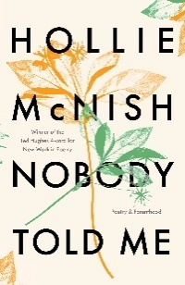
- Organise events and activities based around books from the new list. Here are some ideas:
  - Nobody Told Me: Poetry and Parenthood by Hollie McNish
Hollie’s book contains diary entries and poems that she wrote about her thoughts and feelings becoming a parent. You could run a poetry reading/writing session for new and expectant parents and carers, using Hollie’s writing as a prompt.
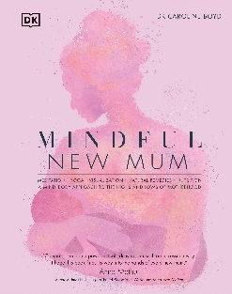
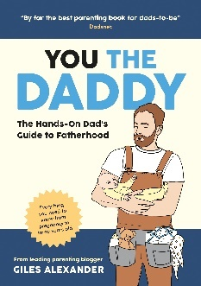
  - Mindful New Mum by Dr Caroline Boyd
Caroline’s book contains evidence-based psychology ideas, meditations, affirmations & visualisations to help mums manage difficult emotions & stay connected with yourself, your baby & your values. Using Caroline’s book as a starting point, you could organise a mindfulness session for new and expectant parents. Or perhaps you could connect with your local authority’s leisure department to run a gentle yoga session in the library for new mums and babies or signpost to where these sessions run in local leisure facilities.
  - You the Daddy by Giles Alexander
Dads can sometimes feel excluded from other parent/ parent and baby groups, so you might organise an event(s) specifically targeting new and expectant dads and carers where they can benefit from peer support. Giles’ book is a great discussion starter to help dads share their own experiences and get to know one another.


- Host an author event with one of the authors featured on the new list. These could be ‘in conversation’ style event where authors share their experience, their books and any advice for supporting parents’ mental health and wellbeing. Authors might also discuss what motivated them to write their book and how reading can support mental wellbeing. (The Reading Well team can help put you in touch with publishers and authors. Author fees should be agreed between the library authority and author. Recommended author fee: £150/travel costs).
- The new book collection could be promoted to parents and carers at the end of Baby Bounce and Rhyme or Storytelling sessions in your libraries.

- If your library runs any other support or social groups for parents and carers, such as Reading Friends, you could talk about the new booklist with the group during or after a session.
- Offer digital drop-in sessions to show people the library e-lending options for the families list, as well as to highlight the recommended digital resources that support the core booklist.

Display and promotion ideas
- Create an eye-catching display of your Darllen yn Well i deuluoedd/ Reading Well for families collection.
- Display copies of leaflets nearby, so people can see the full booklist even when books have been checked-out. You could cut out and display individual descriptions from the overview of the titles to help people decide which book they’d like to borrow.
- Invite local organisations that support new and expectant parents to provide leaflets and information that can be displayed alongside the book collection, and ask if they could share and display Darllen yn Well/ Reading Well leaflets in return.
- Display Darllen yn Well i deuluoedd/ Reading Well for families posters in windows and exterior notice boards to promote the scheme.
- Use a display board for readers’ recommendations and reviews.
- Promotional leaflets could be given to new parents after Bounce and Rhyme and Story Time sessions, or at the same time they collect Bookstart baby packs, if the library supports this.
Any other ideas? Please share your displays and activities with The Reading Agency for evaluation purposes and on social media to inspire others.


Social media and digital promotion
X (Twitter), Instagram, Facebook and other social media platforms, like TikTok, are great ways to tell lots of people about Darllen yn Well i deuluoedd/ Reading Well for families.
As with any booklist, the new Darllen yn Well/ Reading Well scheme may trigger online discussion, which is welcome. Darllen yn Well i deuluoedd/ Reading Well for families is evidence based and quality assured. The booklist and digital resources have been carefully chosen by people with lived experience of perinatal mental health problems, health professionals and library staff to meet the needs of the target audience. You may find it helpful to refer to our FAQs about the scheme.
If you receive any negative feedback on social media or see anything which concerns you, please reach out to comms@readingagency.org.uk and we will support you with a response.
Follow and engage with The Reading Agency and Darllen yn Well/ Reading Well on social media:
- X (Twitter): @readingagency #ReadingWell #DarllenYnWell
- Facebook and Instagram: @readingagency
- LinkedIn: @thereadingagency
- Share images of your displays and activities on X using the #ReadingWell or #DarllenYnWell hashtag.
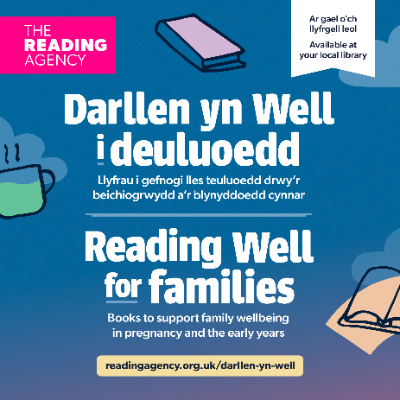
You can use our bilingual digital assets in your social media posts and on your website or in your newsletters to signpost users to the scheme (the folder contains a document with suggested alt text):
- Book jacket composite image
- Social media graphics
- Animated GIF
- Banner artwork
- Short video animation

Template social media posts
X (Twitter)
You can share/adapt the posts suggested below with the digital assets linked above to visually promote the scheme online:
Cymraeg
- Mae #DarllenynWell i deuluoedd yn rhestr lyfrau newydd gan y @readingagency i gefnogi rhieni a gofalwyr gyda'u hiechyd meddwl a'u lles yn ystod beichiogrwydd a'r blynyddoedd cynnar. Ar gael nawr i'w benthyg am ddim gan [YCHWANEGWCH EICH GWASANAETH LLYFRGELL] neu porwch drwy’r rhestr ar-lein yn readingagency.org.uk/darllen-yn-well 📚
- Mae llawer o'r teitlau a argymhellir ar restr lyfrau newydd #DarllenynWell i deuluoedd y @readingagency hefyd ar gael i’w benthyg yn ddigidol 📲
Gofynnwch yn eich llyfrgell i ddarganfod mwy! 🤩
Gallwch bori'r rhestr lyfrau lawn yn: readingagency.org.uk/darllen-yn-well
- Dewch o hyd i wybodaeth a gymeradwywyd gan arbenigwyr yn eich llyfrgell leol i gefnogi eich iechyd meddwl a'ch lles yn ystod beichiogrwydd a'r blynyddoedd cynnar. Darganfyddwch rhestr lyfrau newydd #DarllenynWell i deuluoedd gan y @readingagency: readingagency.org.uk/darllen-yn-well
- Ydych chi'n fydwraig, meddyg teulu, neu ymwelydd iechyd sy'n cefnogi teuluoedd yn y blynyddoedd cynnar? Cyfeiriwch nhw at #DarllenynWell i deuluoedd gan y @readingagency
Llyfrau am ddim ar iechyd meddwl amenedigol a hunan-ofal, ar gael mewn llyfrgelloedd: readingagency.org.uk/darllen-yn-well
English
- #ReadingWell for families is a new booklist from @readingagency to support parents and carers with their mental health and wellbeing in pregnancy and the early years. Available now to borrow for free from [ADD YOUR LIBRARY SERVICE] or browse online at readingagency.org.uk/darllen-yn-well 📚
- Many of the recommended titles on the @readingagency’s new #ReadingWell for families booklist are also available to loan digitally 📲
Ask at your library to find out more! 🤩
You can browse the full booklist at: readingagency.org.uk/darllen-yn-well
- Find expert-endorsed information in your local library to support your mental health and wellbeing in pregnancy and the early years. Discover the new #ReadingWell for families booklist from @readingagency: readingagency.org.uk/darllen-yn-well
- Are you a midwife, GP, or health visitor supporting families in the early years?
Point them to #ReadingWell for families by @readingagency 📚
Free books on perinatal mental health and self-care, available in libraries: readingagency.org.uk/darllen-yn-well
#PerinatalSupport #HealthVisitors #NHS
Facebook and Instagram
Cymraeg

Chwilio am ffyrdd o gefnogi rhieni a gofalwyr gyda'u lles yn ystod beichiogrwydd a'r blynyddoedd cynnar?
Mae'r rhestr lyfrau newydd #DarllenynWell i deuluoedd gan The Reading Agency yn cynnwys teitlau a argymhellir gan banel o bobl sydd â phrofiad byw o anawsterau iechyd meddwl amenedigol, gweithwyr iechyd proffesiynol blaenllaw a staff llyfrgelloedd. Mae'r casgliad wedi'i ddewis yn ofalus i ddarparu gwybodaeth a chefnogaeth ar ofalu am eich lles yn ystod beichiogrwydd a'r blynyddoedd cynnar. Mae'r llyfrau yn darparu gwybodaeth am les, iechyd meddwl ac ymdopi â cholled. Mae rhai o'r llyfrau a argymhellir yn darparu gwybodaeth a chyngor; mae yna hefyd straeon personol, llyfrau darluniadol a barddoniaeth. 📚
Dewch o hyd i'r llyfrau yn eich llyfrgell leol neu drwy bori'r casgliad yn readingagency.org.uk/darllen-yn-well

👶 Ydych chi'n disgwyl neu'n magu plant o dan 2 oed?
Mae eich llyfrgell leol yma i gefnogi eich iechyd meddwl a'ch lles gyda rhestr lyfrau newydd #DarllenynWell i deuluoedd.
Mae'r llyfrau dibynadwy hyn yn cwmpasu popeth o ymwybyddiaeth ofalgar i bryder a galar.
Ar gael o [ENW'R LLYFRGELL] neu ar-lein yn readingagency.org.uk/darllen-yn-well

"Weithiau, y cyfan sydd ei angen arnoch yw stori sy'n dweud 'dydych chi ddim ar eich pen eich hun."
Darganfyddwch rhestr lyfrau #Darllen yn Well i deuluoedd, wedi'i dethol i gefnogi lles rhieni yn y blynyddoedd cynnar.
Am ddim i’w benthyg, ac ar gael yn hwylus.
Dewch o hyd i’r casgliad yn: readingagency.org.uk/darllen-yn-well
@readingagency | #TaithRhianta
Gall blynyddoedd cynnar magu plant newid bywyd – a bod yn anhygoel o anodd. Dyna pam mae Darllen yn Well i deuluoedd yma.
Porwch mewn llyfrau a gefnogir gan arbenigwyr i gefnogi iechyd meddwl a lles yn ystod beichiogrwydd a thu hwnt.
📚 Am ddim i’w benthyg oddi wrth [YCHWANEGWCH EICH GWASANAETH LLYFRGELL] neu porwch ar-lein yn: readingagency.org.uk/darllen-yn-well
#RhieniNewydd #MaterionIechydMeddwl #CymorthRhianta

English

Looking for ways to support parents and carers with their wellbeing in pregnancy and the early years?
The new #ReadingWell for families booklist from The Reading Agency features titles recommended by a panel of people with lived experience of perinatal mental health difficulties, leading health professionals and library staff. The collection has been carefully selected to provide information and support on looking after your wellbeing in pregnancy and the early years. The books provide information on wellbeing, mental health and coping with loss. Some of the recommended books provide information and advice; there are also personal stories, illustrated books and poetry. 📚
Find the books in your local library or browse the collection at readingagency.org.uk/darllen-yn-well

👶 Are you expecting or parenting a child under 2?
Your local library is here to support your mental health and wellbeing with the new #ReadingWell for families booklist.
These trusted reads cover everything from mindfulness to anxiety and grief.
Available from [LIBRARY NAME] or online at readingagency.org.uk/darllen-yn-well

“Sometimes all you need is a story that says ‘you’re not alone.’”
Discover the #ReadingWell for families booklist, curated to support parents’ wellbeing in the early years.
Free to borrow, easy to access.
Find it at: readingagency.org.uk/darllen-yn-well
@readingagency | #ParentingJourney
The early years of parenting can be life-changing – and incredibly tough. That’s why #ReadingWell for families is here.
Browse expert-backed books to support mental health and wellbeing during pregnancy and beyond.
📚 Free to borrow from [ADD YOUR LIBRARY SERVICE] or browse online: readingagency.org.uk/darllen-yn-well
#NewParents #MentalHealthMatters #ParentingSupport
Promotional copy for newsletters and websites
Cefnogwch eich lles yn y blynyddoedd cynnar gyda Darllen yn Well i deuluoedd
Gall magu plant yn y blynyddoedd cynnar fod yn dipyn o daith. P'un ai ydych yn rhiant sy’n disgwyl, yn fam neu’n dad newydd, neu'n gofalu am rai bach, mae eich llyfrgell leol yma i helpu.
O 10 Mehefin 2025, bydd llyfrgelloedd ledled Cymru a Lloegr yn cynnig rhestr lyfrau newydd sbon Darllen yn Well i deuluoedd. Mae'r llyfrau ar gael yn rhad ac am ddim, ac wedi’u hargymell gan arbenigwyr profiadol ac maent yn trafod pynciau fel iechyd meddwl, lles ac ymdopi â cholled.
Yn y casgliad fe welwch chi gyngor ymarferol, straeon personol, llyfrau darluniadol, a barddoniaeth, i gyd wedi'u dewis i'ch cefnogi trwy'r cyfnod hwn. Mae llawer o deitlau hefyd ar gael fel e-lyfrau neu lyfrau llafar.
Benthycwch o'ch llyfrgell neu archwiliwch y rhestr lyfrau ar-lein: www.readingagency.org.uk/darllen-yn-well
Datblygwyd gan The Reading Agency gyda phartneriaid llyfrgelloedd ledled y Deyrnas Unedig a'i ariannu gan Lywodraeth Cymru a Chyngor Celfyddydau Lloegr.
Support your wellbeing in the early years with Reading Well for families
Parenting in the early years can be a rollercoaster. Whether you're an expectant parent, a new mum or dad, or caring for little ones, your local library is here to help.
From 10 June 2025, libraries across Wales and England will be offering a brand new Reading Well for families booklist. These free, expert-recommended reads cover topics like mental health, wellbeing and coping with loss.
You’ll find practical advice, personal stories, illustrated books, and poetry, all chosen to support you through this time. Many titles are also available as e-books or audiobooks.
Borrow from your library or explore the booklist online: www.readingagency.org.uk/darllen-yn-well
Developed by The Reading Agency with library partners across the UK and funded by Welsh Government and Arts Council England.
Local press
You can download a template press release to help promote your Darllen yn Well i deuluoedd/ Reading Well for families collections in the local area.

Promotion opportunities throughout the year
There are several relevant awareness campaigns throughout the year when you could shine a spotlight on your library’s collections. Engaging with an awareness campaign can be as simple as posting on social media and using the campaign hashtag and tagging the organisation that runs the campaign.
Some campaigns that you could engage with include:
- Parent Mental Health Day (January)
An annual campaign promoting awareness of the critical link between parents’ mental health and family wellbeing. Coordinated by stem4.
- Maternal Mental Health Week (May)
A week-long campaign dedicated to talking about mental health problems before, during and after pregnancy. Coordinated by the Perinatal Mental Health Partnership.
- Infant Mental Health Awareness Week (June)
Provides an annual opportunity to discuss the importance of supporting babies’ mental health and wellbeing. Each year the campaign has a new theme. Coordinated by the Parent-Infant Foundation.
- Baby Loss Awareness Week (October)
A week for remembrance as well as raising awareness of the impact of pregnancy and baby loss, the importance of bereavement support and the work that is needed to improve pregnancy outcomes and to save babies’ lives. More than 120 charities are part of the Baby Loss Awareness Week Alliance.
- Baby Week (November)
Baby Week is a registered charity and aims to bring sectors and services together to promote the best start in life. By celebrating services and raising awareness about the importance of early childhood, Baby Week aims to make UK the best place to grow up in.

Health sector outreach
The resources below have been created to help libraries connect with local health partners and services, and alert them to Darllen yn Well/ Reading Well and the wider public library offer.
- Social prescribing toolkit: A toolkit to help library staff develop their social prescribing offer. It includes an overview of social prescribing, and guidance on working with partners and Link Workers locally.
- Social prescribing infographic: Library social prescribing offer infographic, customisable for a local service context.
- Health sector engagement letter: Can be used to promote the new and existing Reading Well booklists to local GP surgeries and community health professionals and establish partnerships to deliver Darllen yn Well/ Reading Well.
- Digital screen artwork: Can be shared with local GP surgeries and other health settings to help them promote the new Darllen yn Well i deuluoedd/ Reading Well for families scheme.


Feedback
We’d love to hear what readers think of the books!
- Insert Darllen yn Well i deuluoedd/ Reading Well for families leaflets into the books.
- Encourage readers to leave feedback on our website.
If you have any queries about the launch or resources, please get in touch with the Reading Well team: readingwell@readingagency.org.uk

